**ST. THEREZA NAMIRYANGO GIRLS’ BOARDING PRIMARY SCHOOL**

**END OF TERM I CONTINUOUS ASSESSMENT 2024**

**P.1 LITERACY**

**TIME ALLOWED: 2 HOURS 15 MINUTES**

**NAME____________________________________________STM__**

**SECTION A**

1. Domestic animals are animals kept at **___________**.

2. Name this fruit we eat at home.

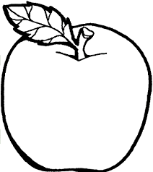 **___________**

3. Who cooks food at home?

**___________________________________________________**

4. How does a P.1child keep the classroom clean?

by**_________________________________________________**

5. We use **___________** for washing our cups and plates.

6. Give the use of a broom when cleaning the house.

**___________________________________________________**

7. How many fingers do you have?

**___________________________________________________**

8. Write the best food for babies.

**___________________________________________________**

9. We get ivory from an **______________________** .

10. Why do people keep goats at home?

**____________________________________________________**

11. Name this activity done by P.1children after learning

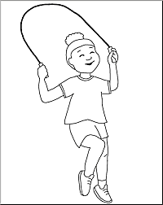 **_____________**

12. Write any one person we find in the hospital.

**__________________________________________________**

13. What is the colour of your teeth?

**__________________________________________________**

14. Which animal guards our home?

**__________________________________________________**

15. Name the plant that provides us with bananas.

**___________________________________________________**

16. Why do animals move?

**__________________________________________________**

17. What do we call the animals that live in the bush or forest?

**___________________________________________________**

18. Beef is to a cow as chicken is to a **___________** .

19. Name this item used to keep water for drinking at school.

**_____________**

20. Where should P.1 pupils put rubbish after picking it?

**___________________________________________________**

21. Write the young one of a duck .

**___________________________________________________**

22. Mention any one place where wild animals live.

**___________________________________________________**

23. How does a bird move?

**___________________________________________________**

24. What does a P.1child do after eating food with her hands?

**___________________________________________________**

25. Write any one animal that provides milk topeople.

**___________________________________________________**

26. How do we care for animals at home?

**__________________________________________________**

27. Write any one thing a mother uses in the kitchen.

**___________________________________________________**

28. Give the use of a hoe to a farmer.

**___________________________________________________**

29. Which animal lives in a pig sty?

**___________________________________________________**

30. Mention the animal that eats rats at home.

**________________________________________________**

31. Name this childhood immunisable disease that causes this effect.

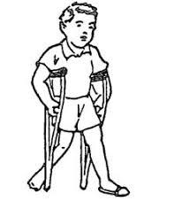**_________________________**

32. Write the work of children at home.

**_______________________________________________**

33. Why does a P.1 child wash hands after visiting the toilet?

**__________________________________________________**

34. Draw this plant.

|  |
| --- |
|  |
| mango plant |

35. Write any one thing a P.1 child uses to wash her dress.

**___________________________________________________**

36. How many legs does a sheep have?

**___________________________________________________**

37. Mention any one thing used to clean the classroom.

**___________________________________________________**

38. How are legs useful to people?

**___________________________________________________**

39. Write any one item found in the bedroom.

**__________________________________________________**

40. How do we keep our bed sheets clean?

**___________________________________________________**

**SECTION B**

41(a) Name the domestic animal drawn below.

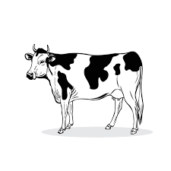 **____________________**

(b) Write any two things we get from the animal above.

i) **_____________________** ii) **____________________**

(c) Where does the above animal live?

**________________________________________________**

42(a) What do we call things which have no life?

**________________________________________________**

(b) Give any two examples of things which have no life.

i) **_____________________** ii) **____________________**

(c) Why is a stone called a non-living thing?

**_________________________________________________**

43(a) Name these things used to clean our bodies .

|  |  |  |  |
| --- | --- | --- | --- |
| Towel Line Art Stock Illustrations – 11 ... |  |  |  |
|  |  |  |  |

44. Which body sense organ do we usefor the following?

hearing: **______________**

feeling: **_______________**

smelling: **______________**

seeing : **_______________**

45(a) Name these domestic birds.

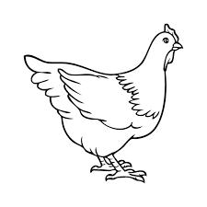 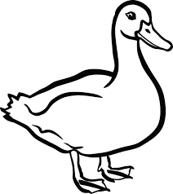

**______________ _____________**

(b) Give any two things we get from these domestic brids

i) **_____________________** ii) **____________________**

46(a) Draw these physical body exercises.

|  |  |  |
| --- | --- | --- |
|  |  |  |
| dancing | swimming | standing |

(b) Why do we do physical body exercises?

**_______________________________________________**

47(a) Name the parts of the house.

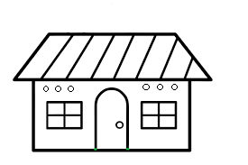

1. **____________**

2. **____________**

3**.____________**

**2**

**1**

**3**

(b) Write one thing we use to clean the house.

**_______________________________________________**

48. Write “**Yes**” or ”**No**”

i)Living things have life **________**

ii)We use water for bathing **_________**

iii) A nurse cooks food **________**

iv)We eat food to die **_______**

49.  **Name these parts of the head .**

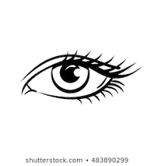 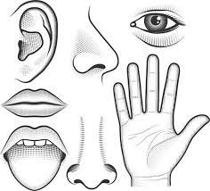 

**__________ _________**

 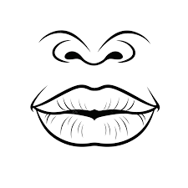

**___________** **____________**

50(a) **Write the item used for** :-

i) combing the hair **_______________________**

ii) brushing the teeth **_______________________**

iii) washing our face **_______________________**

(b) How do we keep our teeth clean?

**______________________________________________**

51(a) Write any two animals which eat grass .

i) **_____________________** ii) **____________________**

(b) Which animals move by:

i) crawling **___________________**

ii) running **___________________**

52(a) Name this thing used to clean our hair.

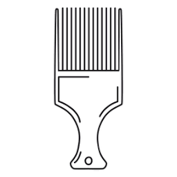**________________________**

(b) How do we keep our hair clean?

**________________________________________________**

(c) Where do P.1 pupils bathe from?

**________________________________________________**

(d) Write one thing used to clean our bathroom.

**________________________________________________**

53(a) Write any two plants found at school.

i) **_____________________** ii) **____________________**

b) Give any two things we get from plants.

i) **_____________________** ii) **____________________**

54(a) Write any two examples of common diseases.

i) **_____________________** ii) **____________________**

(b) Who takes care of sick people at school.

**________________________________________________**

(c) Write one place where we find nurses.

**________________________________________________**

55. **Match the animal to its sound.**

dog roars

baby hisses

snake barks

lion cries

**++End++**